Quiz no. 3

Question no. 1:   
  
A signal has passed through three cascaded amplifiers, each with a 4 dB gain.  
What is the total gain? How much is the signal amplified?

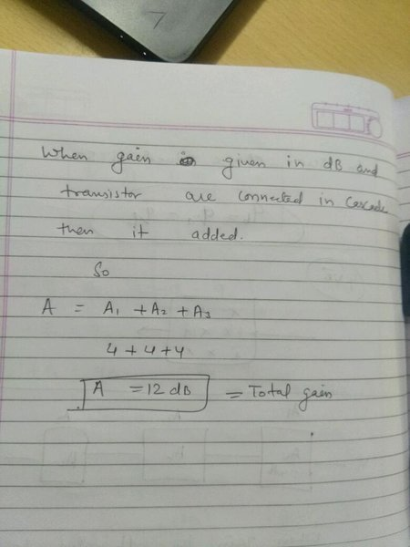

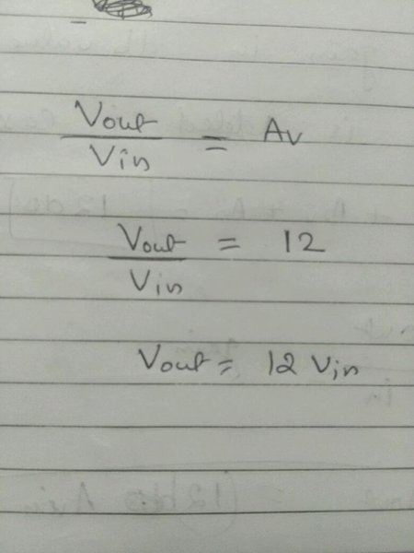

Question no. 2: We measure the performance of a telephone line (4 KHz of bandwidth). When the signal is 10 V, the noise is 5 mV. What is the maximum data rate supported by this telephone line?

4000 \* log2(10,000/5) =43500 bps

Question no. 3: A device is sending out data at the rate of 1000 bps.  
a. How long does it take to send out 10 bits?  
b. How long does it take to send out a single character (8 bits)?  
c. How long does it take to send a file of 100,000 characters?

ANSWER:

how long does it take to send out 10 bits?  
100/1000 = 0.01 sec  
  
How long does it takes to send out a single character of 8 bits?  
8/1000 = 0.008 sec  
  
How long does it take to send a file of 1000000 characters?  
As, single character is of 8 bits.So,  
{8\*1000000}/1000 = 8000 sec